
Original Spanish handmade boots
available through Los Caballos del Mosquin
Order form
Date:

Client Information
Name:
Delivery adress:
Country
Email:

Product
Personalized: |  |  |  |  |  | Standard:
Ref.nr.: |  |  |  |  |  | Ref.nr.:
Personal measurements: |  |  |  |  |  | Size:
Number*  1  2  3  4  5  6  7 | Left Foot |  | Right foot |  | 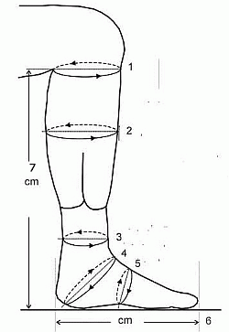
*The number refers to the number on the drawing of the leg.
Important: Make sure, you take the accurate measurements.
If you wish wollen socks, jeans in the boots, extra inlayers etc. please calculate with space enough in the measurements you give us. Any alterations in the standard models will cause in no return right, except fault in manufacturing.

Payment
Means of Payment: | Paypal/Creditcard |  | Banktransfer
Price:
Price:
Postage:
Extra cost for personalizing
Total:
Transfer

Please read the ”Purchase Procedure” before you fill in the order form regarding Personalizing, measurements and payment details.

